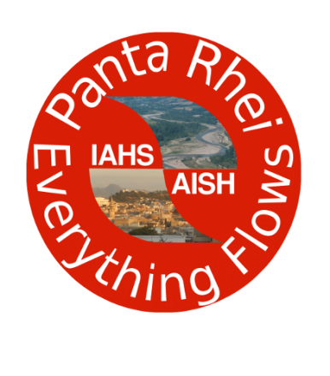 | Panta Rhei – Everything Flows  Change in Hydrology and Society  IAHS Scientific Decade 2013-2022  www.iahs.info/pantarhei

[The first two pages of this template contain guidelines and should be removed when submitting the proposal]

Proposal for a Working Group
Premise
The activity of Panta Rhei will be carried out by Working Groups that will refer to Research Themes. Working Groups will be listed in this page as they are approved by the Panta Rhei Chair and Target Leaders. A first list of Working Groups will be compiled after January 31st, 2014 (see below).
Call for Working Groups
The Panta Rhei community is invited to submit proposals for Working Groups that will be developing the research activity of the Panta Rhei Scientific Decade 2013-2022.
Working Group focus on Research Themes (see the Panta Rhei web site for the list of Panta Rhei Research Themes) and therefore they also establish a link with the Panta Rhei targets and research questions.
Composition of Working Groups
Working Groups are expected to be composed by at least 6 researchers from at least 3 different countries. They are coordinated by a Chair who is expected to keep the connection with the Panta Rhei Chair and Target Leaders. It is highly recommended that the expertise of Working Group member is complementary therefore allowing an interdisciplinary approach to research.
Task of Working Groups
Working Groups are expected to promote the research activity of Panta Rhei. They should produce a sufficient number of papers containing an explicit acknowledgement to Panta Rhei (see the Panta Rhei web page for a list of papers and instructions on how to acknowledge Panta Rhei). Moreover, Working Groups are expected to organise international initiatives and symposia with the patronage of Panta Rhei (sessions at AGU and EGU meetings, summer schools, small scale workshops etc.). They should also produce an annual report of the activity that will be published on the IAHS web site.
Working Groups may be removed if they fail in providing a sufficient activity.
Proposing a Working Group
Working Groups can be proposed anytime during the first biennium of Panta Rhei (2013-2015). However, startup Working Groups can be proposed until January 31st, 2014. After that date a first summary of Working Groups will be compiled and the present web page updated. If you are interested to propose a Working Group, this first deadline should not be missed. Proposals that will be submitted later on will be considered as long as they fill a significant gap in the overall configuration of the Working Groups that have already been approved.

Please submit this proposal by January 31st, 2014 as an email attachment to alberto.montanari@unibo.it. A confirmation of receipt will be sent to you.

Panta Rhei – Everything Flows
Change in Hydrology and Society
IAHS Scientific Decade 2013-2022
www.iahs.info/pantarhei

Details of the Proposal
Title of the Working Group
(Please use a short title identifying a broad subject. Es: Floods in Historical Cities)

Abstract of the proposed research activity
(Please write an abstract of max 150 words. Be synthetic but clear in identifying the research questions).

Panta Rhei Research Themes, Targets and Science Questions addressed by the Working Group
(Please see the Panta Rhei web site for the list of Panta Rhei Research Themes, Targets and Science Questions)

Societal impact of the Working Group activity
(Please write max 150 words describing the societal impact of the working group activity and any connections with stakeholders (potential or already established)).

List of Participants
Please include at least 6 members from 3 different countries. Make an effort to ensure interdisciplinarity. Add rows at the Table if necessary.
Name of Participant | Affiliation (full address and email) | Role in Working Group (Chair or Member) | Main expertise
1
2
3
4
5
6

