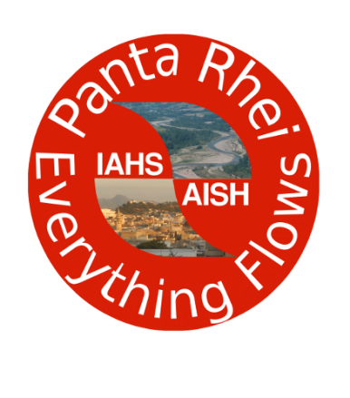 | Panta Rhei – Everything Flows  Change in Hydrology and Society  IAHS Scientific Decade 2013-2022  www.iahs.info/pantarhei

[The first page of this template contain guidelines and should be removed when submitting the proposal]
Proposal for a Research Theme
Premise
The research ctivity of Panta Rhei is structured in research themes that will refer to the targets of Panta Rhei. Research themes will be listed in the Panta Rhei web site as they are approved by the Panta Rhei Chair and Target Leaders. A first list of Research Themes will be compiled after January 31st, 2014 (see below).
Call for Research Themes
The Panta Rhei community is invited to submit proposals for Research Themes to be developed during the Panta Rhei Scientific Decade 2013-2022.
Research Themes are driven by one or more broad research questions and are described by a short abstract (no more than 150 words) describing the related activity and the link of the theme with the Panta Rhei Science Questions, with particular emphasis on the connection with society. Finally, proposers of a Research Theme should provide a first list of related working groups. If no groups are available, the proposers of the Research Theme are expected to submit at the same time a proposal for a working group (please see the Panta Rhei web site).
Research themes can be proposed anytime during the first biennium of Panta Rhei (2013-2015). However, startup Research Themes can be proposed until January 31st, 2014. After that date a first summary of research themes will be compiled and the related web page updated. If you are interested to propose a research theme, this first deadline should not be missed. Proposals that will be submitted later on will be considered as long as they fill a significant gap in the overall configuration of the Research Themes that have already been approved.
Please submit this proposal by January 31st, 2014 as an email attachment to alberto.montanari@unibo.it. A confirmation of receipt will be sent to you.
Panta Rhei – Everything Flows
Change in Hydrology and Society
IAHS Scientific Decade 2013-2022
www.iahs.info/pantarhei

Details of the Proposal
Title of the Research Theme
(Please use a short title identifying a broad subject. Es: Floods and Society)

Abstract of the research theme
(Please write an abstract of max 150 words. Be synthetic but clear in identifying the research questions).

Panta Rhei research Targets and Science Questions addressed by the Research Theme
(Please see the Panta Rhei web site for the list of Panta Rhei Targets and Science Questions)

Societal impact of the Research Theme
(Please write max 150 words describing the societal impact of the research theme and any connections with stakeholders (potential or already established)).

Panta Rhei Working Groups referring to the Research Theme
Please see the list of the Panta Rhei Working Groups in the Panta Rhei web site. The list will be available from February 2014. If you are submitting your proposal for the Research Theme before than the list is made available, please indicate here whether or not you are also proposing a Working Group to address your proposed Research Theme.

